**DAILY ONLINE ACTIVITIES SUMMARY**

|  |  |  |  |  |  |  |  |  |
| --- | --- | --- | --- | --- | --- | --- | --- | --- |
| **Date:** | **02-07-2020** | | | | | **Name:** | **Rohan Mahaveer** | |
| **Sem & Sec** | **6th B** | | | | | **USN:** | **4AL17CS077** | |
| **Online Test Summary** | | | | | | | | |
| **Subject** | | **-** | | | | | | |
| **Max. Marks** | | **-** | | **Score** | | | **-** | |
| **Certification Course Summary** | | | | | | | | |
| **Course** | **Cyber Security** | | | | | | | |
| **Certificate Provider** | | | **Udemy** | | **Duration** | | | **9 hrs** |
| **Coding Challenges** | | | | | | | | |
| **Problem Statement:**  1. Python Program to check whether a given number is a fibonacci number or not | | | | | | | | |
| **Status:** YES, Completed all Programs | | | | | | | | |
| **Uploaded the report in Github** | | | | | **YES** | | | |
| **If yes Repository name** | | | | | <https://github.com/rohanmahaveer/daily-status> | | | |
| **Uploaded the report in slack** | | | | | **YES** | | | |

Certification Course Details:

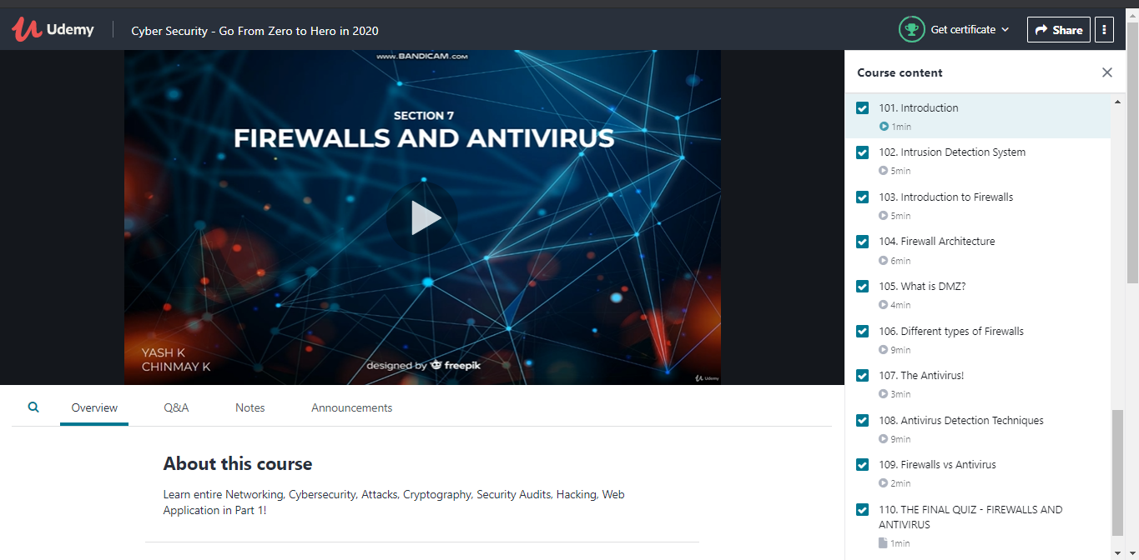

Today in certification I have learnt about Firewalls and Antivirus.

Coding Challenges Details:

Program1:

